**Linn Conservancy**

**Celebrates 25 Years**

Join us on Saturday, Oct 19 from 1-3:30pm at the Campus Theatre as the Merrill Linn Conservancy, our parent organization, marks its 25th anniversary. This will be both a celebratory event with snacks, drinks and birthday cake for all as well as an opportunity for the Conservancy to publicly introduce its *Linking Landscapes Initiative*. Clyde Peeling of Reptiland as well as Mizuki Takahashi and Tristan Stayton of Bucknell University will be on hand with live animal displays. Clyde’s presentation regarding the *Linking Landscapes Initiative* will begin about 1:30. We (BCWA) will have our display board there to promote our mission and encourage membership. We hope to see you there to support both organizations.

**Local Business Owners   
Raise Funds for BCWA**

Tedd and Sharon Biernstein owners of the Smiling Chameleon Draft House on Market Street in Lewisburg are supporting local waterways projects through the sale of koozies to help keep your summer beverages cold. Tedd grew up playing in local waterways and continues to enjoy our area’s rivers and streams as a kayaker, fisherman and cabin owner along Penns Creek. As an example of good stewardship, Tedd always does a bit of “river keeping” during his outings by picking up a bit of trash in the waterways and by encouraging—or insisting—that those in his company do the same.

***Like us on Facebook***

The koozies are available at the Smiling Chameleon, Buffalo Valley Outdoors (Vargo’s) and at Reptiland. Tedd will donate 100% of sales to the Buffalo Creek Watershed Alliance of the Merrill Linn Conservancy. We thank Tedd and Sharon for their support. To read more about their promotion visit

[www.smilingchameleon.com](http://www.smilingchameleon.com) and click on “Things We Care About.”

**Fish Returning**

**to Upper Reaches of the Main Branch**

A recent fish survey conducted by Steve Means of the North Central Office of DEP noted a significant increase in the fish population downstream of BCWA’s acid rain remediation site. Shanon Stamm, Union County watershed specialist, writes, “The surveys went very well!!  Great numbers and variety of age classes of brook trout.  Unfortunately the Fish and Boat Commission was not along for the Gooseneck area sampling. They have to be present for the sampling to list the stream as Class A wild brook trout stream.  So the bottom reach (Aikey road to just past the ponderosa) will likely get reclassified while the rest of the stream will remain as a wild trout stream.”

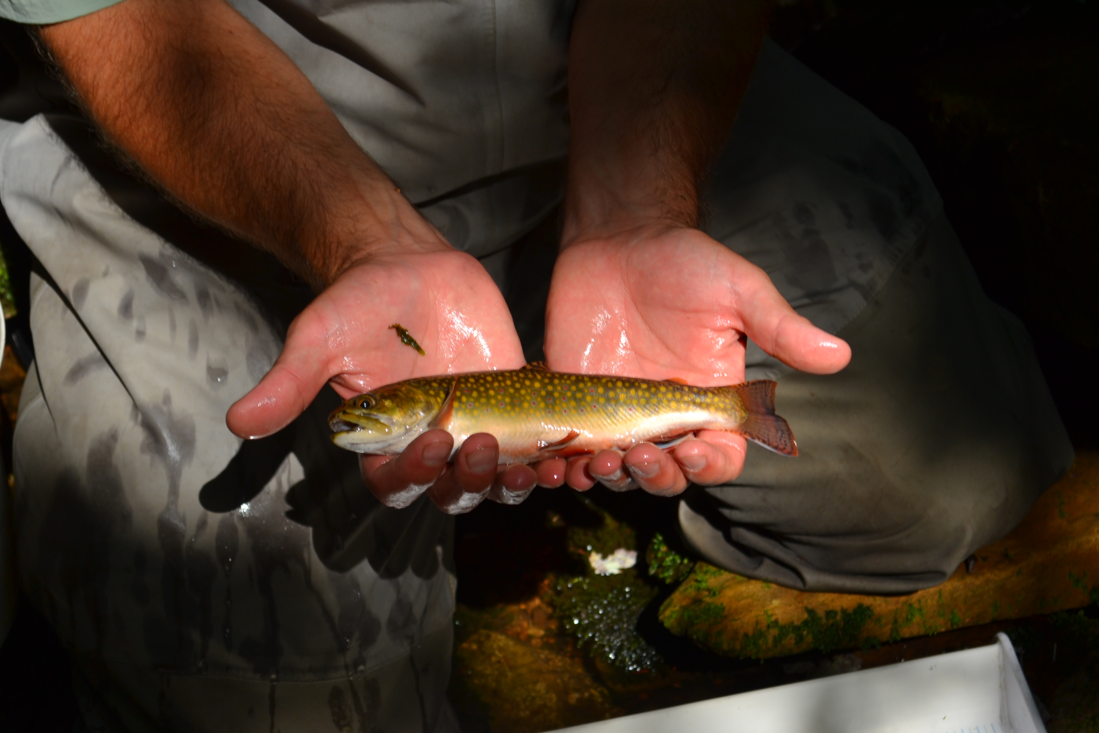

*Brook Trout Caught During Fish Survey Near Frederick’s Gap*

**Remediation Site Maintenance**

On Saturday September 28 four members of BCWA spent a beautiful fall morning at the remediation site taking care of some maintenance tasks. The remaining lime was spread over the soil on the site. It was noted that the grasses growing on the site were very thick and hardy. This was attributed to the lime that was spread last year. This was very encouraging to see the site becoming well covered. This will help in discouraging invasive species from growing on the site. We did check for invasive species of plants and found that thistle was still growing in some areas and these were treated with RoundUp. Finally, we surveyed the site for survival of trees that we had planted the past two springs. We were able to find 19 white pine, 7 white spruce, and 6 red osier dogwood. We also noted that there are other native species growing on the site as "volunteers". We found several Virginia pine, oak, and maple trees. Many thanks to the volunteers who helped with these tasks.

  
*Steve Miller, Jim Sanders, and   
Warren Abrahamson at Remediation Site*

*Photo by Edwena Eger*

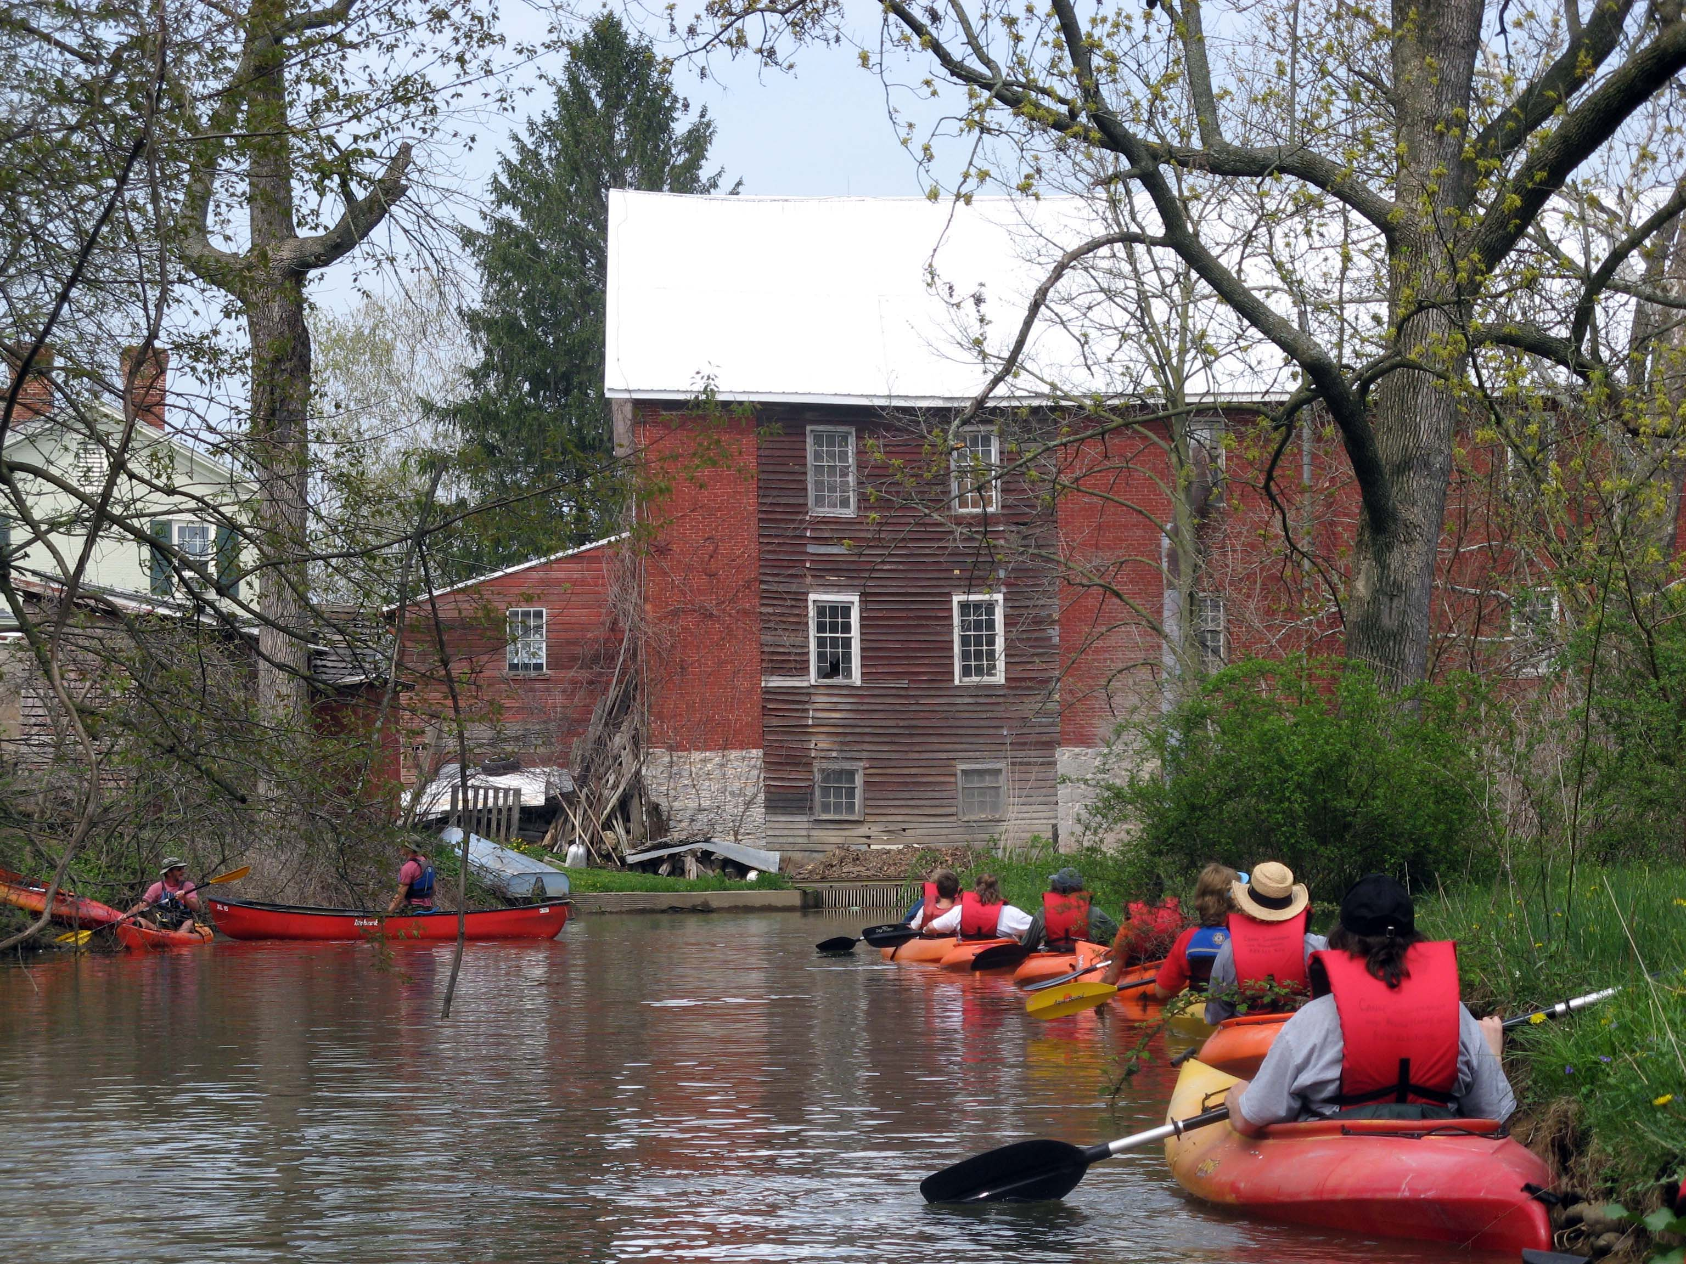

*Canoe and Kayak Adventurers*

*in the Mill Race at Grove’s Mill*

**Webmaster Needed**

If you have basic skills for the maintenance of a website BCWA could use your help. We are looking for someone willing and able to update our website and/or Facebook page about once a month. Please respond to [allan.grundstrom@gmail.com](mailto:allan.grundstrom@gmail.com).

**Please Renew Your Membership**

You will receive shortly a letter from the Linn Conservancy asking you to renew your membership. In your response we ask that you once again check the box designating ten dollars for your BCWA membership. The support of members like you is our main source of funds and is vital to keeping our activities going.

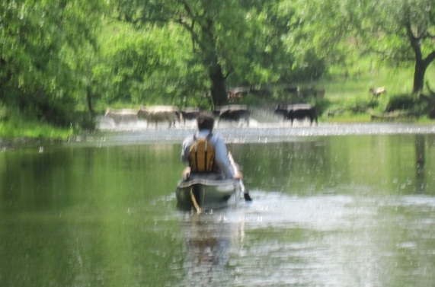*John Capwell Approaches a Herd of Cattle Crossing Buffalo Creek   
Near Hoffa Mill Road*